IMA application will be supported in IE browser only. Please use the respective browser and try installing the proper java version from the following link and set the following details:
https://drive.google.com/file/d/124Eyg9sbEN9n9ma4NSTGDXmy3SUIS_uA/view?usp=sharing
- IMA Applet will support with 32-bit JDK 1.6.0_51 to JDK 1.7.0
  - Please download the said version from above shared drive URL.
- IE browser compatibility set for the domain
- Make sure that URL “ https://ima.centurylink.com/ima “is added in the exception site list (Path: Control Panel->Java->Security-> exception site list)
- Enable the java content in the browser option (Path: Control Panel->Java->Security-> select the “Java content in the browser” check box).
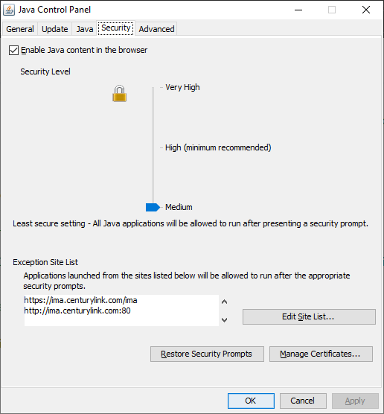
- TSL checks in advanced settings (find the attached screenshot)
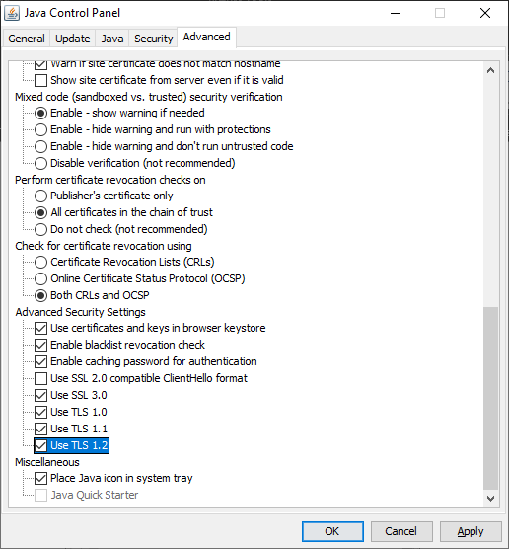

- Required “QwestIMACertificate.p12” certificate under the path C:\users\ (User ID) \. Password for the certificate is “qwest1”.
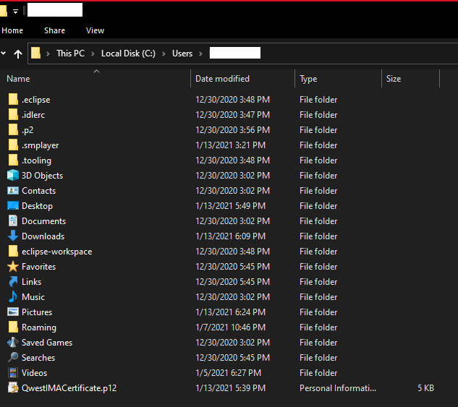
- In Internet Explorer settings, open “Internet Options” -> “Security”
There we need to add “https://ima.centurylink.com/ima” in ”Trusted Sites” and uncheck “Require Server Verification”
After all the set-up is done, then open IMA application URL(https://ima.centurylink.com/ima) and check the following option.
